**COMSATS University Islamabad, Lahore** **Campus**

**Lab Assignment -II- Spring 2023**

|  |  |  |  |  |  |  |  |  |  |  |
| --- | --- | --- | --- | --- | --- | --- | --- | --- | --- | --- |
| Course Title: | Software Project Management | | | | | Course Code: | CSE494 | | Credit Hours: | 3(2,1) |
| Course instructor/s: | Sobia Usman | | | | Programme Name: | | BS SE | | | |
| Semester: | 7th | Batch: | SP20-BSE | Section: | A, B | | Date: | 4-4-2023 | | |
| **Dead Line** | 9-4-2023 | | | | **Maximum Marks:** | | | **10** | | |

***CLO: <5>; Bloom Taxonomy Level: <Creating>***

**Statement:**

Create the project plan and Gantt chart for your Final year project of one year duration.

1. Add tasks and sub tasks
2. Add task dependencies
3. Create work, material and cost resources
4. Assign resources to subtasks
5. Identify the critical path of this project

Submission:

Take screenshots of the above mentioned tasks separately and submit in MS word file with assignment title page.

Software Project Management

Lab Assignment # 2

SUBMITTED BY:

|  |  |
| --- | --- |
| nAME | ROLL NO |
| sAMEER REHMAN | SP20-BSE-050 |
| muhammad aashir bilal | SP20-BE-054 |

**1.Click on Summary on Task Bar**

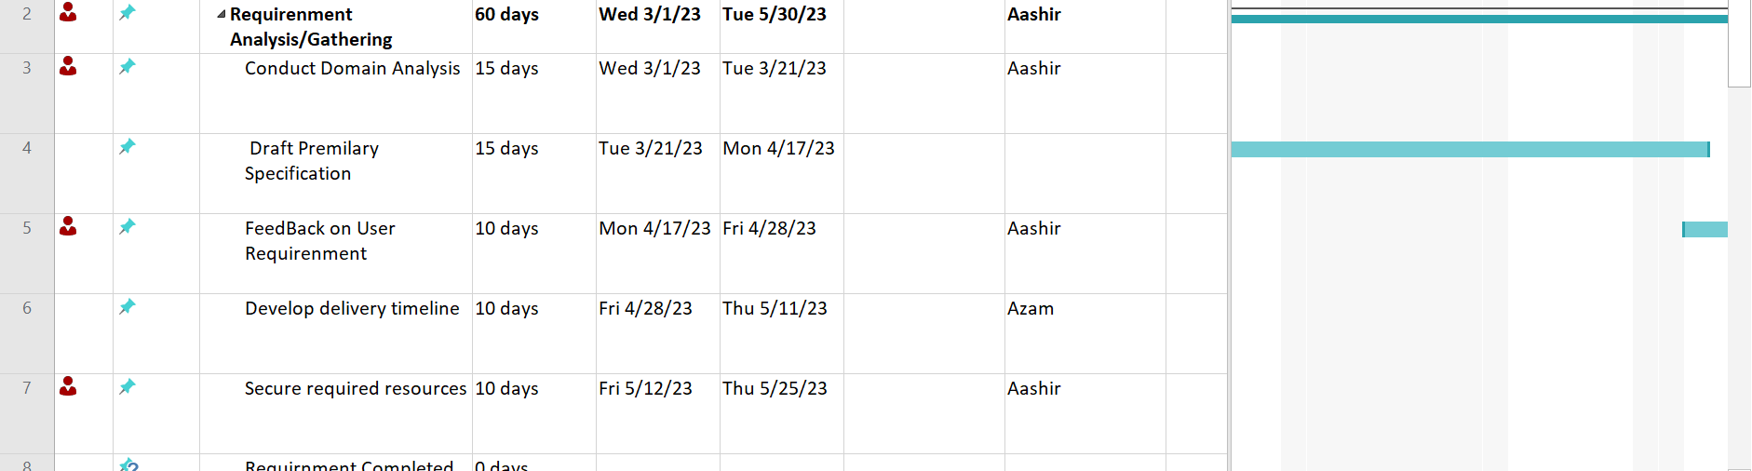

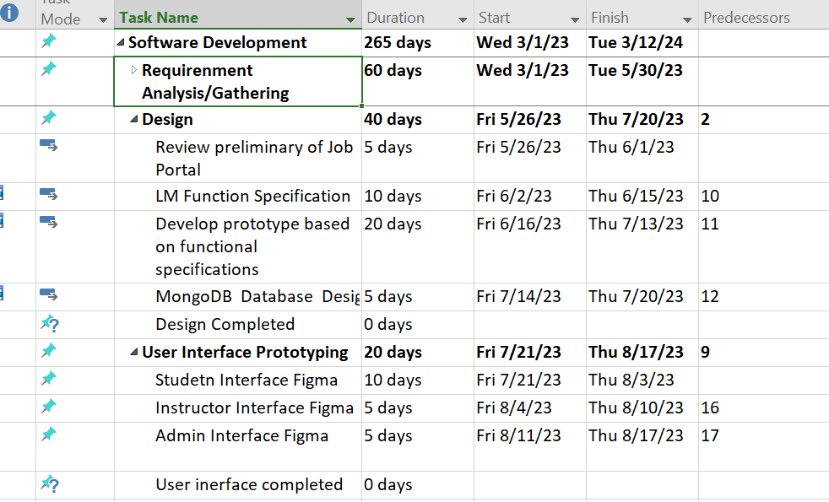

**2.Click on Task Dependency**

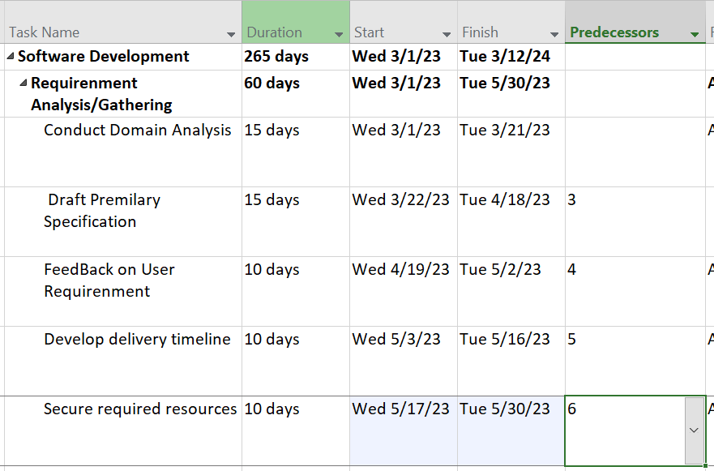

**3.Create Work and Material**

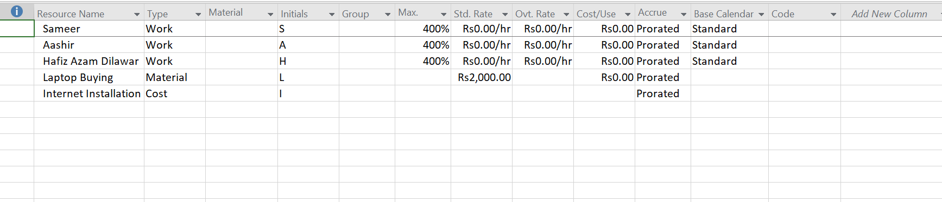

**4.Assign resources to subtasks**

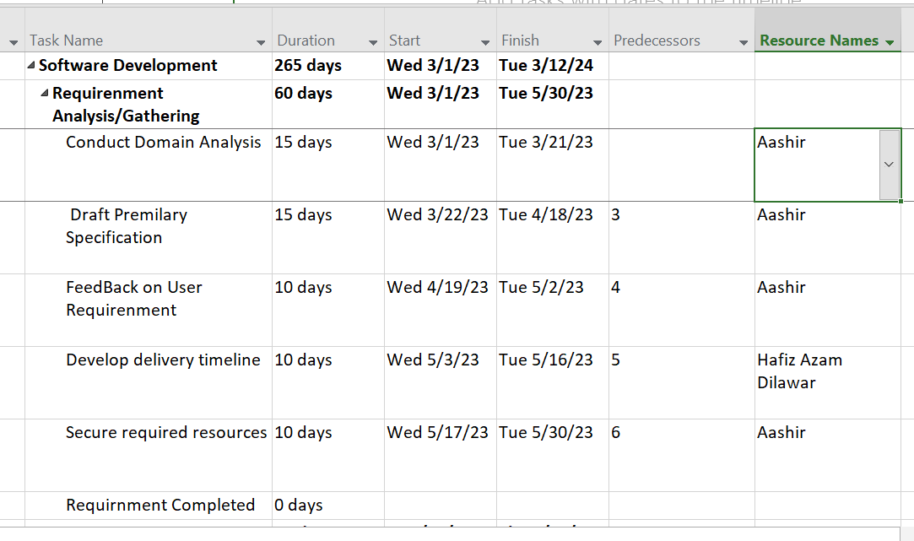

**5.Identify the Critical Path**

